Thank you for your interest in INTERACT data.
Please send your completed proposal and any questions to Enal Hindi ehindi@bsd.uchicago.edu
Date
Proposal Title
Principal Investigator
Institution
Cooperative Group / Data Contributor | - COG  - EuPAL  - JCCG  - St. Jude  - Not a member of one of these Groups
E-Mail Address
List of anticipated  co-authors /  co-investigators | Name | Institution
Are you including an early career investigator? | - Yes  - No  Note, your local definition should be used
If you are not including an early career investigator, please explain
Statistician Name
Statistician E-Mail
Statistician institution
Statistician Affiliation | - COG  - EuPAL  - JCCG  - St. Jude  - Not a member of one of these Groups - CV attached.  If you would like to perform the analysis locally, in lieu of using a statistician or data analyst from one of these groups, please include the CV of your statistician
Project Timeline | All investigators requesting data should ensure that the project is completed within a reasonable timeframe. Every effort should be made to meet the time points outlined below:  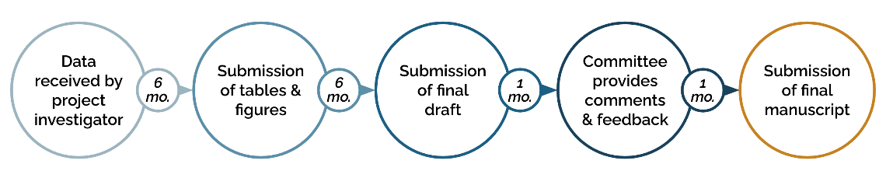  *Projects not submitted to the Committee within 1 year will be evaluated for reassignment to other interested investigators
If you foresee challenges in adhering to this timeline, please describe
Data Portal Usage | Did you utilize the PCDC Data Portal Cohort Explorer Tool to determine study feasibility or sample size for this project?  ❏ Yes  ❏ No
Did you utilize the PCDC Data Portal Kaplan-Meier Survival Analysis Tool for early hypothesis exploration for this project?
❏ Yes
❏ No
If you utilized the Kaplan-Meier Survival Analysis Tool, have you attached the relevant entries from your personal hypothesis record along with the project request?
❏ Yes - attached
❏ No - not applicable

Please format your project proposal as follows:
Please limit your request to 3 pages

- Specific Aims
- Hypothesis
- Patient Cohort (Eligibility Criteria)
- Background
- Significance
- Proposal description
- Statistical plan (statistical methodology used to assess the aims)
- Data Requested [please refer to the data dictionary to define the specific data elements requested.]

