Thank you for your interest in NODAL data.
Please send your completed proposal and any questions to Suzi Birz suzi@uchicago.edu

Date
Proposal Title
Principal Investigator
Institution
Cooperative Group | - Children’s Oncology Group (COG)  - Pediatric Hodgkin Consortium (St. Jude-Stanford-Dana-Farber)  - Not a member of one of these Groups
E-mail Address
List of anticipated co-authors / co-investigators | Name | Institution
Are you including a YI? | - Yes  - No
If you are not including a YI, please explain
Statistician name
Statistician institution
Statistician e-mail
Statistician Affiliation | - Children’s Oncology Group (COG)  - Pediatric Hodgkin Consortium (St. Jude-Stanford-Dana-Farber)  - Not a member of one of these Groups - CV attached  - If you would like to perform the analysis locally, in lieu of using a statistician, data manager or data analyst from one of these groups, please include the CV of the individual
Project Timeline | All investigators requesting data should ensure that the project is completed within a reasonable timeframe. Every effort should be made to meet the time points outlined below: 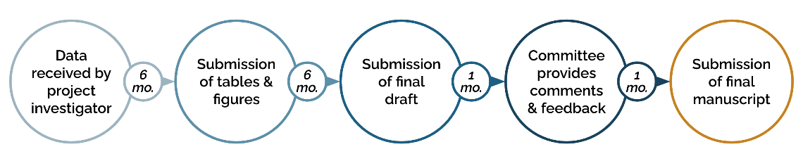  *Projects not completed within 2 years will be evaluated for reassignment to other interested investigators
If you foresee challenges in adhering to this timeline, please describe
If applicable, please share funding sources

Data Portal Usage | Did you utilize the PCDC Data Portal Cohort Explorer Tool to determine study feasibility or sample size for this project?  - Yes  - No
Did you utilize the PCDC Data Portal Kaplan-Meier Survival Analysis Tool for early hypothesis exploration for this project?
- Yes
- No
If you utilized the Kaplan-Meier Survival Analysis Tool, have you attached the relevant entries from your personal hypothesis record along with the project request?
- Yes - attached
- No - not applicable

Please format your project proposal as follows:
Suggested page limit = 5 pages maximum

- Specific Aims
- Hypothesis
- Patient Cohort (Eligibility Criteria)
- Background
- Significance
- Proposal description
- Statistical plan – including:
  - Tables and figures, if known
  - Profile of the output / results desired
- Data Requested [please refer to the data dictionary to define the specific data elements requested.]

