Thank you for your interest in HIBiSCus data.
Please send your completed proposal and any questions to:
Kat Blumhardt kblumhardt@peds.bsd.uchicago.edu
Proposal title
Principal Investigator
Institution
Cooperative Group affiliation | - CESS  - COG  - COSS  - EEC  - GALOP  - GEIS | - GSF-GETO  - ISG  - NCRI  - SFCE  - SSG  - UNICANCER
 | - Not a member of one of these Cooperative Groups
E-mail address
Co-authors
Are you including an early career investigator?  *your local definition should be used | - Yes | - No
If you are not including an early career investigator, please explain
Statistician name or plan for identifying a statistician
Statistician e-mail
Statistician institution
Statistician affiliation | - CESS  - COG  - COSS  - EEC  - GALOP  - GEIS | - GSF-GET)  - ISG  - NCRI  - SFCE  - SSG  - UNICANCER
- Not a member of one of these Cooperative Groups - CV attached

If you would like to perform the analysis locally, in lieu of using a statistician or data manager from one of the data contributors, please include the CV of your statistician.
Project timeline | All investigators requesting data should ensure that the project is completed within a reasonable timeframe. Every effort should be made to meet the time points outlined below.  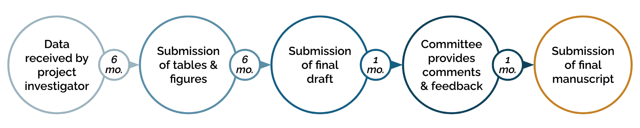
If you foresee challenges in adhering to this timeline, please describe

Please format your project proposal as follows.
Kindly limit your proposal to 3 pages (items 1-7) using at least 11 pt font.
- Specific Aims
- Hypothesis
- Patient Cohort (Eligibility Criteria)
- Background
- Significance
- Proposal Description
- Statistical Plan
- Data Requested [please refer to the data dictionary to define the specific data elements requested]

